South Sudan

## Freedom House political status

The data set shows the Freedom House political scores and status of the country each year.

## # A tibble: 19 x 5  
## country iso3c date mean status   
## <chr> <chr> <dbl> <dbl> <chr>   
## 1 South Sudan SSD 1996 1 <NA>   
## 2 South Sudan SSD 1998 1 <NA>   
## 3 South Sudan SSD 2000 1 <NA>   
## 4 South Sudan SSD 2002 1 <NA>   
## 5 South Sudan SSD 2003 1 <NA>   
## 6 South Sudan SSD 2004 1 <NA>   
## 7 South Sudan SSD 2005 1 <NA>   
## 8 South Sudan SSD 2006 1 <NA>   
## 9 South Sudan SSD 2007 1 <NA>   
## 10 South Sudan SSD 2008 1 <NA>   
## 11 South Sudan SSD 2009 1 <NA>   
## 12 South Sudan SSD 2010 4 <NA>   
## 13 South Sudan SSD 2011 5.5 Not Free  
## 14 South Sudan SSD 2012 5.5 Not Free  
## 15 South Sudan SSD 2013 6 Not Free  
## 16 South Sudan SSD 2014 6.5 Not Free  
## 17 South Sudan SSD 2015 6.5 Not Free  
## 18 South Sudan SSD 2016 7 Not Free  
## 19 South Sudan SSD 2017 7 Not Free

## Freedom House classification of political change

The data set shows the GDP growth and the ecomic growth classification of the country each year.

## # A tibble: 19 x 4  
## country iso3c date politicalChangeFH  
## <chr> <chr> <dbl> <chr>   
## 1 South Sudan SSD 1996 <NA>   
## 2 South Sudan SSD 1998 <NA>   
## 3 South Sudan SSD 2000 <NA>   
## 4 South Sudan SSD 2002 <NA>   
## 5 South Sudan SSD 2003 <NA>   
## 6 South Sudan SSD 2004 <NA>   
## 7 South Sudan SSD 2005 <NA>   
## 8 South Sudan SSD 2006 <NA>   
## 9 South Sudan SSD 2007 <NA>   
## 10 South Sudan SSD 2008 <NA>   
## 11 South Sudan SSD 2009 <NA>   
## 12 South Sudan SSD 2010 <NA>   
## 13 South Sudan SSD 2011 no change   
## 14 South Sudan SSD 2012 no change   
## 15 South Sudan SSD 2013 autocratization   
## 16 South Sudan SSD 2014 autocratization   
## 17 South Sudan SSD 2015 no change   
## 18 South Sudan SSD 2016 autocratization   
## 19 South Sudan SSD 2017 no change

## Freedom House score trend

The plot shows the Freedom House scores trend of the country.

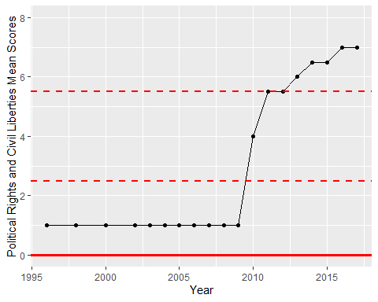

Freedom House Score Trend